TRACEMYHOUSE.COM
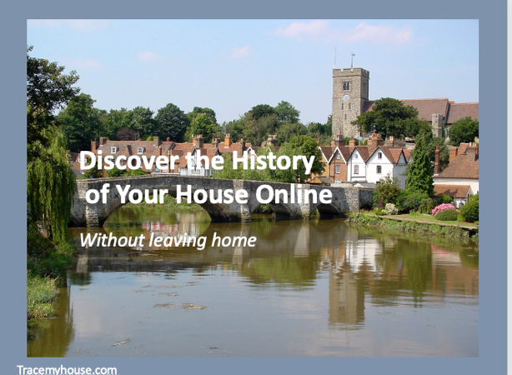
Discover the History of Your House Online Without leaving the house

Here are the links that are mentioned in the video

GENERAL HELP AND ADVICE

For general help, links and ideas go to Trace My House and follow the links

Interested in tracing the history of your house go to Getting started

AGE AND ARCHITECTURAL STYLES
For help to find out more about the architectural styles of old houses
go to How old is my house.com

For help to find out more about how to age your house - How to date your house
Architectural house styles - howoldismyhouse.com

LAND REGISTRY
- Learn more about the Land Registry on Trace my House
- Go to the official Land Registry web site

WARNING: If you search for the Land Registry site you will find there are several sites that seem to be the Land Registry but only one is the official government site. They will search for your property but at a price higher than the government one.

MAPS
Learn more about Maps on Trace my House
More useful map links
- Ordnance Survey
- Cassini Maps
Check the historical social class of your London street using Charles Booth’s poverty maps, compiled between 1886 and 1903
The Genealogist has Map Explorer as part of its collection of map based records. This overlays historic maps on a modern background.
National Library of Scotland – great map collection for whole UK

STREET AND TRADE DIRECTORIES
Learn more about Street Directories on Trace my House
Go to the University of Leicester Historical Trade and Street Directories
Directories on Ancestry

CENSUS
Learn more about Census on Trace my House
More useful census links
- Free Cen
- Family Search
- Find My Past Census 1841-1911
- Ancestry Census 1841-1911
- My Heritage
- The Genealogist

Find My Past have a button on all their census pages which allow you to search for an address direct. No more searching for someone by name, you can go straight to an address if it existed in that census year.

For more about how to find an address in the census go to our blog

ELECTORAL ROLLS
- FindmyPast
- FindmyPast also have a maps search page which visualises the 1939 address data.
- Ancestry

1910 VALUATION SURVEY
Find out more about the 1910 Valuation Survey on Trace My House
- Advice from the National Archives

WILLS
Learn more about Wills and Probate on Trace my House
- Wills on Ancestry

BOOKS
If you would like to know more about tracing the history of your house, we recommend the following books

- House Histories: The Secrets Behind Your Front Door Melanie Backe Hansen
- Historic Streets and Squares - Melanie Backe Hansen
- Tracing your House History - Gill Blanchard
- Tracing the History of Your House: The Building, the People, the Past - Nick Barratt
- Ideal Homes - Uncovering the History and Design of the Interwar House (Studies in Design and Material Culture) by Deborah Sugg Ryan

USEFUL LINKS
House History at Historic England site | Local Guides by County at Trace my House
Houses at the National Archives | Property Records at Irish Genealogy
Scotland Places | Public Record Office Northern Ireland
British History On Line | House History in Wales

Although we make every effort to ensure these links are accurate, up to date and relevant, Trace My House cannot take responsibility for pages maintained by external providers. ©2020 TracemyHouse.com and Come in Handy Group

